Mohammed Ashraf Taha – 617027 – 4CS

QZ.1

Answer 1:

Answer 2:

Answer 3:

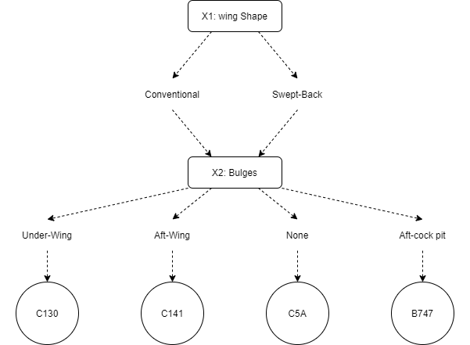Answer 4:

R1: **IF** Wing Sheap Conventional **And** Bulges Under – Wing **THEN** C130

R2: **IF** Wing Sheap Conventional **And** Bulges Aft-Wing **THEN** C141

R3: **IF** Wing Sheap Swept-Back **And** Bulges None **THEN** C5A

R4: **IF** Wing Sheap Swept-Back **And** Bulges Aft-cock pit **THEN** B747

Answer 5:

